Pharmaceutical Chemistry II.
Lecture I. "Analeptic means"

Analeptics (from the Greek analepticos — restoring) are drugs that have a strong stimulating effect on the respiratory and vascular centers of the medulla oblongata.
Analeptics are mainly used in medicine to stimulate the respiratory center. The name analeptic (from the Greek analepticos means restoring, strengthening, strengthening) was given to them because of this property, that is, it stimulates the inhibited respiratory center and accelerates breathing. All representatives of this group have a general stimulating effect on the CNS (brain and spinal cord) and cause convulsions in high doses. Therefore, they are often called general brain stimulants or seizure-causing agents.
The stimulating effect of analeptics on the brain or spinal cord is based on the improvement of the process of inter-neuronal (synaptic) transmission of nerve impulses and, as a result, the strengthening of the arousal processes, or the weakening of the inhibition processes. In other words, analeptics stimulate CNS neurons either directly or by causing disinhibition (preventing or inhibiting existing inhibition).
The stimulating effect occurs directly (caffeine, camphor, bemegrid, cytisine) or by increasing their sensitivity (strychnine), which stimulates important respiratory and circulatory functions. Some analeptics can also stimulate other centers of the CNS, which can cause convulsions in case of overdose.
The main use of analeptics, discovered at the beginning of the 20th century, was related to the overdose of barbiturates. Until the 30s of the last century, natural stimulants, such as camphor, were used for this purpose. From the 1930s to the 1960s, synthetic analeptics were proposed, such as nikethamide, pentylenetetrazole, bemegrid, amphetamine, and methylphenidate. These substances replaced natural preparations.
Strychnine should be mentioned as one of the first widely used preparations from the group of analeptics. This substance exerts its effect by acting against glycine. Strychnine was used until the beginning of the 20th century, but its use was restricted after its high toxicity was discovered.
Doxapram is considered the first representative of respiratory analgesics. This substance increases respiratory volume and respiratory rate after intravenous use. However, its use has been reduced in recent years. This is due to certain side effects of this substance.
Analeptic drugs mainly stimulate breathing by 4 mechanisms of action:
1. By blocking potassium channels (doxapram). These substances increase respiration by affecting the potassium channels of the carotid bodies. Blockade of potassium channels leads to opening of voltage-gated calcium channels and release of neurotransmitter.
2. Ampakines are considered the second form of analeptics. They combine with AMPA (alpha-amine-3-hydroxy-5-methyl-4-isoxazolepropionate) receptors located in the pre-Betsinger complex and increase the number of respirations.
3. Antagonists of serotonin receptors. These substances combine with serotonin receptors and provide an analytical response.
4. Adenosine antagonists (purine derivatives). Adenosine is known to inhibit respiration by blocking the electrical activity of respiratory neurons. As an adenosine antagonist, caffeine stimulates these neurons and has an analeptic effect.
According to the principle of localization of their effects, some representatives of this group show more tropism against the brain (for example, camphor, niketamide), while others (for example, strychnine) show tropism against the spinal cord structures. Therefore, convulsive seizures caused by individual representatives of analeptics in high doses have a different character, depending directly on the mechanism of action of the respective drugs. For example, the drugs that play a crucial role in the mechanism of action of the brain structures mainly cause clonic (convulsions of individual muscle groups), while the drugs that affect the spinal cord, as a rule, cause tonic (tetanic) convulsions. The drugs included in the first group can cause mixed seizures of clonic-tonic type in very high doses. It was established experimentally (as a result of comparative studies on intact animals and spinal animals with the spinal cord cut off from the brain) that strychnine-induced convulsions are caused by direct spinal stimulation, while seizures caused by centrally acting drugs are the result of brainstem and cerebral cortex awakening (supraspinal stimulation). appears. One of the individual and common features of centrally acting drugs in therapeutic doses is the property of showing a higher tropism towards the longitudinal brain centers (respiratory and vascular movement) compared to other brain structures. Regardless of the mechanism of action, all analeptics can induce coughing and sneezing by stimulating the cough center at high therapeutic doses and during intravenous injection.
The molecular mechanism of the stimulating effect of analeptics (including convulsions) is associated with the blockade of GAYT or glycine receptors in the brain, or the blockade of the GAYT/benzodiazepine receptor complex, or the slowing down of GAYT synthesis and presynaptic release (here, the role of other mechanisms unknown to science is denied). cannot be done). For example, picrotoxin acts by weakening the postsynaptic mechanisms of GAYT, which functions as an inhibitory mediator in the CNS (by blocking chlorine channels connected with GAYT receptors). Another classic representative of the group of analeptics - the action effect of strychnine appears as a result of blockade of postsynaptic glycine receptors, etc.
Although in medical practice, analeptics are mainly used based on their effects on the respiratory center (weakness of breathing, during asphyxia, in mild poisoning with sleeping pills, analgesics and other substances that have an inhibitory effect on the CNS, etc.), the total peripheral resistance of the vessels increases during the appointment of these drugs. , blood pressure rises, and as a result of all this, the general blood circulation in the body, as well as the blood supply of the body can improve. Therefore, these drugs are used to reduce vascular tone, acute and chronic blood circulation disorders, shock during surgery and post-surgery, etc. is also determined in cases.
Classification of analeptics according to the mechanism of tonic effect on the respiratory center.
1. Direct stimulators of neurons of the respiratory tract:
Bemegrid, caffeine, etmizol, strychnine, securin.
2. Analeptics with reflex action (N-cholinomimetics):
Lobeline, cytisine.
3. Direct and reflex effective (mixed) analeptics:
Camphor, Niketamide (cordiamine)

Chemical classification of analeptics:
1) Preparations based on ammonia:
Alcohol (10% aqueous solution of ammonia)
2) Amide derivatives
Pretamide
3) Bicyclic terpenoids
Camphor, sulfacamphocaine
4) Aromatic compounds
Modafinil, Armodafinil
5) Piperidindione derivatives
Bemegrid
6) Alkylated acid amides (amides of nicotinic acid)
Nikethamide (Cordiamine)
7) Purine derivatives
Caffeine, theophylline
8) Imidazole derivatives
Etimizol
9) Tetrazole derivatives
Corazol (Pentylenetetrazole)
10) Indole derivatives
Strychnine, securinine
11) Morpholine derivatives
Doxapram
12) Piperidine derivatives
Lobelin, Methylphenidate
13) Quinolizide derivatives
Cytisine (Cititon)
Information about representatives of individual groups.
Preparations based on ammonia:
NH4OH
Alcohol (10% aqueous solution of ammonia)
It is a colorless, transparent solution with a characteristic smell.
It stimulates the respiratory and vascular-motor center in the medulla oblongata by awakening the sensitive nerve endings of the upper respiratory tract. Increases breathing rate, increases arterial pressure. At high concentrations, it can cause reflex cessation of breathing. As an analeptic, it is used during syncope, during short-term fainting. It is released in vials in the form of a solution for external use.

Amide derivatives
Pretkamide (Mikoren)
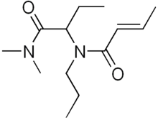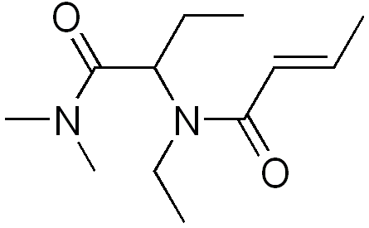
Cropropamide Crotetamide
A respirator consisting of two similar substances is a respiratory stimulant. It was proposed by the Ciba-Geigy company back in 1953. It directly affects the respiratory center.
It has low bioavailability (24-32%), it is quickly removed from the body. It is used in certain lung diseases and lung failure.
Overdose can lead to agitation, tremors, convulsions, headaches, paresthesia, vomiting, increased breathing and dyspnea.
It is administered orally, intravenously and intramuscularly.

Bicyclic terpenoids
Camphor.

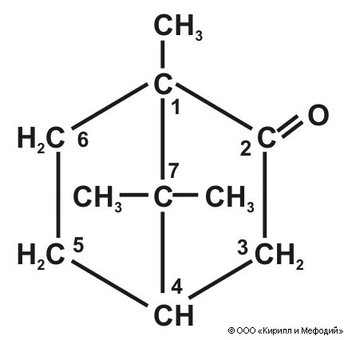

1,7,7-trimethylbicyclo[2.2.1]heptan-2-one
Camphor is one of the main representatives of analeptics. For medicinal purposes, German natural dextrorotatory camphorane (d) from the camphor (camphor) tree is used, as well as the synthetic levorotatory (l) isomer and racemate form of the drug obtained from white pine oil
 Camphor tree
Synthesis of camphor from bornyl acetate:
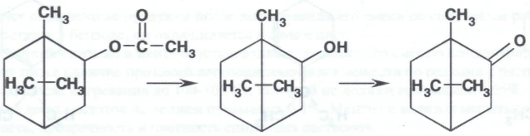
Bornyl acetate borneol camphor
Synthesis of camphor from pinene:

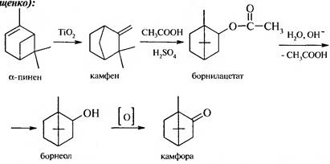
camphor
pinene
During parenteral injection into the body, it awakens the respiratory and motor vascular center, has a stimulating effect on the heart muscle. According to A.S. Saratikov's research, camphor strengthens exchange processes in the myocardium and increases its sensitivity to the influence of the "sympathetic nerve". Under the influence of the drug, peripheral blood vessels are toned.
As it is removed from the body through the respiratory tract, it improves the release of sputum during the corresponding pathologies. Camphor has the ability to block the aggregation of platelets. This, as a drug that improves microcirculation, further expands the possibility of using the drug in the future
Metabolism of camphor:

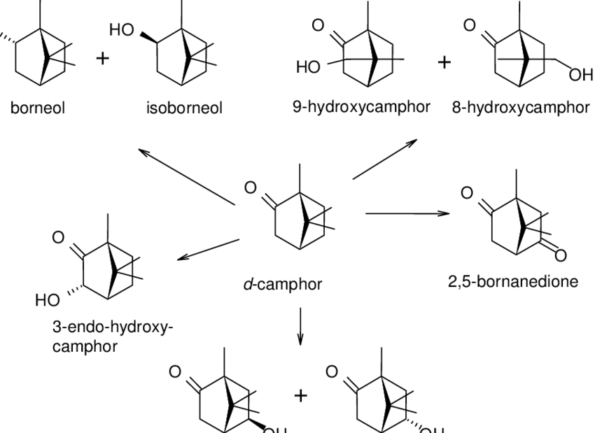

Oxidation products of camphor combine with glucuronic acid and are excreted through the kidneys. Part of the camphor is excreted unchanged by the lungs or bile.
Camphor solution is used in the complex treatment of acute and chronic heart failure, collapses, blockage of breathing that may occur during pneumonia, poisoning with sleeping pills and narcotic drugs, as well as during the treatment of some infectious diseases. For this purpose, the following preparations of camphor are used: 20% fatty solution of camphor (in peach or olive oil) for injection, 10% fatty solution of camphor (in sunflower oil) for external treatment, camphor ointment, camphor alcohol, camphor and salicylic acid. alcohol solution, camphocin liniment, "denta" tooth drops.
Sulphocamphocain 10% solution for injection.
It is a medicine consisting of two components.
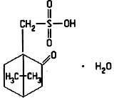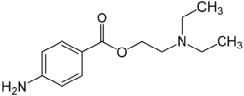
Sulphocamphoric acid Procain
(49,6 part) (50,4 part)
It is an analeptic drug. The mechanism of action is connected to the centers of the medulla both directly and through the carotid sinus. The drug awakens the respiratory and motor centers, strengthens the exchange processes in the heart muscle, increases blood flow to the heart, improves coronary blood circulation, increases blood supply to the brain and lungs.
When injected into the body, it is rapidly absorbed. Since it is painful, it is used in combination with procaine. As a result of metabolism, it is oxidized and excreted as a conjugate with glucuronide. Metabolites are mainly excreted by the kidneys, at which time the urine has a specific smell. A small amount is excreted through respiration and bile.
It is mainly used during acute and chronic respiratory failure, heart failure, cardiogenic and anaphylactic shock, alcohol poisoning, poisoning with sleeping pills.
It is used as an injection, prescribed subcutaneously, intravenously and intramuscularly.
Aromatic compounds
Modafinil (Provigil)
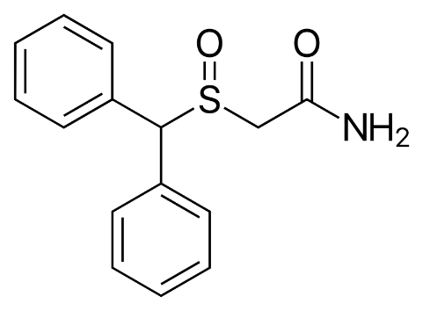
(±)-2-(diphenylmethyl)-sulfinylacetamide.

It is an analeptic used to treat drowsiness associated with narcolepsy. Its wider non-medical use is known - as a relatively safe psychostimulant. It is used by military personnel and cosmonauts to relieve sleepiness and fatigue. There is information on its use for weight loss. In some states, it is included in the list of psychotropic substances.
Modafinil is a racemate mixture of two enantiomers:
(R)-modafinil - called armodafinil, is used in the same way as the individual medicine (Nuvigil)
(S)-modafinil is called esmodafinil.
Benzhydrol is used as a starting material for the industrial synthesis of Modafin:
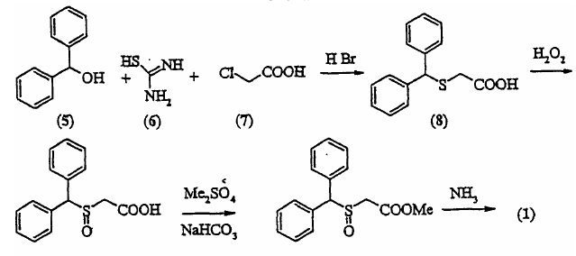
Modafinil's mechanism of action is not fully understood. It is believed to increase the synthesis of monoamines (mainly catecholamines) from synaptic clefts. It also increases the level of histamine in the hypothalamus.
Modafinil is metabolized in the liver and excreted through the kidneys in the form of inactive metabolites.
Metabolism of Modafinil:
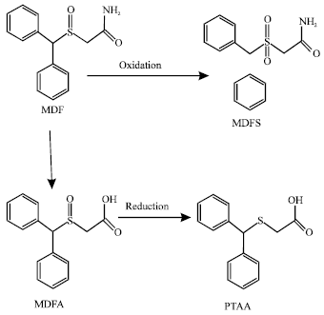
It is used in tablet form.

5) Piperidindione derivatives
Bemegrid
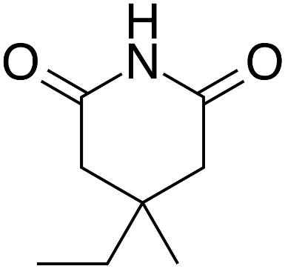
4-Ethyl-4-methyl-2,6-piperidinedione
Bemegrid is a derivative of 2,6-dioxypiperidine by its chemical structure, and is widely used as an analeptic agent (intravenous doses of 0.5% solution in doses of 2-5 ml) during pathologies observed with respiratory blockage. It is considered an active antagonist of hypnotics (especially barbiturates). Reduces the toxicity of barbiturates, prevents respiratory and circulatory suppression by these substances. The drug has a stimulating effect on the CNS. Its activity is higher than that of Niketamide and Camphor.
When prescribing the drug to children, the dose is reduced by the ratio of the average body weight of adults to the body weight of children. Violation of dosage during the use of Bemegrid can lead to the appearance of unwanted symptoms such as nausea, vomiting, muscle movements and seizures. The use of the drug during psychomotor alertness is contraindicated.
6) Alkylated acid amides (amides of nicotinic acid) Nikethamide (Cordiamine)
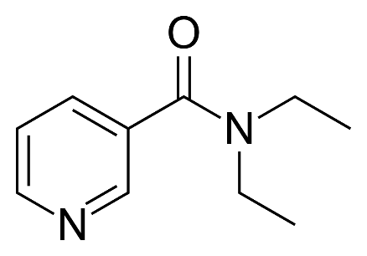
Diethylamide of nicotinic acid (diethylnicotinamide)

The chemical structure of Niketamide is diethylnicotinamide (25% diethylamide solution of nicotinic acid). It is a colorless or weakly yellowish or weakly greenish colored, transparent solution with a characteristic smell. They sterilize at +100 °C for 30 minutes.
Synthesis of cordiamine:
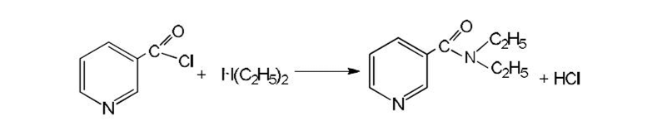
The drug has a mixed effect. It has both central and peripheral effects. By stimulating the CNS, the drug awakens the respiratory and motor vascular centers. It has no direct vasoconstrictor and cardiac stimulant effects, and can cause cyanotic seizures in very high doses.
It has high absorption. In the body, it undergoes metabolism in the liver and is excreted through the kidneys in the form of inactive metabolites. It is used to prevent breathing during collapse and asphyxia, during shock after surgical operations, during infectious diseases.
It is administered orally (orally, before meals) and parenterally. Adults are prescribed 15-40 drops each time (orally), 2-3 times a day. For children, age-appropriate doses are prescribed (1 drop per age). Parenteral (subcutaneous and intramuscular) administration of Niketamide is painful. Therefore, in some cases, 1 ml of 0.5-1% procaine solution is pre-injected into the injection area of ​​nicetamide in order to reduce the feeling of pain. The drug is contraindicated for people prone to convulsions. Currently, in most countries of the world, Niketamide is not used as an analeptic.
Purine derivatives
The purine nucleus is formed from imidazole and pyrimidine rings. It has two isomers 9H-purine and 7H-purine:

7
H
N
N
N
N
H
9
8
7
6
5
4
3
2
1
N
N
N
N

9H-purine 7H-puine

Purine alkaloids are derivatives of xanthine (2,6-dioxypurine). Xanthine exists in two forms - enol (1) and ketone (II):
O
H
N
O
H
N
N
N
O
N
H
O
N
N
N
H
H
H
I
I
I

Caffeine and theophylline belong to the purine alkaloids.

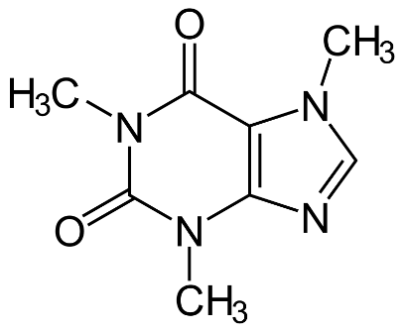 1,3,7-trimethylxanthine

Caffeine was first obtained from coffee seeds and tea leaves by Runge in 1819, by Theophilus Kossel in 1889.
These alkaloids are found in tea (Thea chinensis L.) leaves, coffee (Coffea arabica L.) and cola seeds, as well as cocoa beans. Tea leaves and coffee beans contain up to 1-3% caffeine. In addition to caffeine, tea leaves also contain small amounts of theobromine, theophylline, and

xanthine. Caffeine is obtained from tea dust and scraps, which are produced as waste in tea production.
There are several methods of obtaining caffeine from natural raw materials. One method is countercurrent extraction. Aqueous extract is cleaned of impurities, ballast substances are precipitated with the help of lead, calcium and magnesium salts. The filtrate is evaporated. Caffeine is obtained by recrystallization from cooled aqueous solutions.
Complete chemical synthesis was proposed by the German scientist Traube in 1900
N
H
3
C
C
N
H
3
H
C
O
+
C
C
H
2
C
N
O
O
H
-
H
2
O
C
O
N
3
H
C
O
N
H
C
H
3
C
N
H

C
O
N
3
H
C
O
N
C
H
3
C
H
2
N
H
N
O
H
O
-
H
2
O
C
O
N
3
H
C
O
N
C
H
3
N
H
N
O
H
[
H
]
C
O
N
3
H
C
O
N
C
H
3
N
H
2
N
H
2

H
C
O
O
H
-
H
2
O
C
O
N
3
H
C
O
N
C
H
3
N
H
2
N
H
C
O
H
N
a
O
H
-
H
2
O

C
O
N
3
H
C
O
N
C
H
3
N
N
H
(
C
H
3
)
2
S
O
4
C
O
N
3
H
C
O
N
C
H
3
N
N
C
H
3

Semi-synthesis method.
Uric acid, which is used as a raw material here, is obtained through synthesis as a result of condensation of urea and acetal at a temperature of 1100 C or from bird droppings (guano). Its amount in bird's bell reaches 25%.
When uric acid is treated with formamide, xanthine is obtained, which is methylated under certain conditions to synthesize caffeine and theobromine. The methylation process in the production of caffeine is carried out at pH 8-9, and in theobromine at a temperature of 60-700 C with the participation of KOH and methanol:
H
N
H
O
N
H
N
H
O
N
H
N
H
O
N
H
N
O
N
O
H
C
O
N
H
2
formamid

Caffeine is a white shiny, needle-like crystal or white crystalline powder, with a bitter taste. It gradually loses its water of crystallization in the air. Sublimes when heated. It is gradually soluble (1:60) in water, slightly soluble in hot water and chloroform, moderately soluble in alcohol, very slightly soluble in ether.
Metabolism of caffeine:
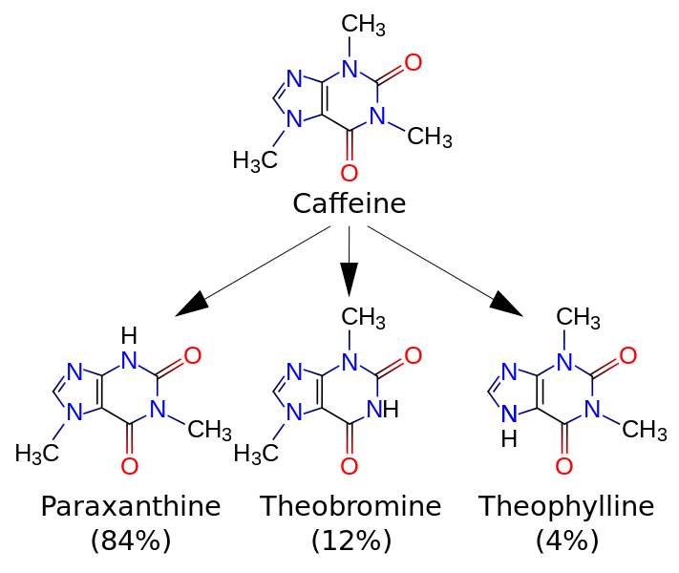

Caffeine, a representative of the methylxanthines group, is one of the substances that has a strong stimulating effect on the respiratory center located in the medulla oblongata (theophylline, another methylxanthine derivative, has a similar effect). Since the psychostimulant component (as a result of the effect on the cerebral cortex) is stronger in the general spectrum of effects of caffeine, this substance belongs to the group of psychomotor stimulants.
Caffeine is used in medicine to relieve physical fatigue, to treat drug poisoning, to treat various heart diseases, to stimulate the nervous system, and to strengthen breathing and blood circulation. A small amount of caffeine is included in drugs that eliminate headaches (citromon, ascofen). Caffeine is also found in the fruits (pods) of the kola plant. The famous tonic Coca-Cola drink is made from these plant extracts. Caffeine has the same effect on the human body: it increases mental and physical work capacity, relieves temporary fatigue, drowsiness, strengthens heart activity, metabolism, causes narrowing of blood vessels and an increase in blood pressure. It is for this reason that people prone to hypertension (high blood pressure) are not advised to consume a lot of chocolate and tonic drinks.
Caffeine (caffeine sodium benzoate)
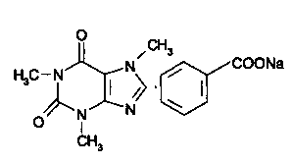
It is a white powder, odorless and slightly bitter taste. Easily soluble in water, moderately soluble in alcohol.
To get the preparation, they mix aqueous solutions of caffeine (40%) and sodium benzoate (60%) and evaporate to a dry residue.
The preparation is prescribed in the case of weakening of heart activity, weakness of awakening and transmission in the heart, and shock state during various diseases, chronic myocarditis, myodystrophies, chronic myodegenerations. It is used as a vasodilator during spasm of cerebral and cardiac vessels. It is used in the form of an injection solution.

Theophylline
1,3-dimethylxanthine
.
O
N
3
H
C
O
N
C
H
3
N
N
H
2
O
H

It is a white crystalline powder, odorless. It is slightly soluble in water, 95% alcohol, ether and chloroform, easily soluble in hot water and 95% hot alcohol, soluble in acids and alkalis.
Synthesis of theophylline:
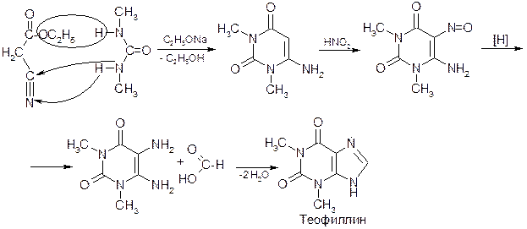

Theophylline has a stimulating effect on cardiac activity, increases the strength and number of heartbeats, improves coronary blood circulation, and increases the oxygen demand of the myocardium. It is used in the form of capsules and tablets. Theophylline has a spasmolytic (vases, bronchial dilation), diuretic, CNS stimulating effect. Increases myocardial contractile activity. Theophylline is more widely used as a long-acting drug, rather than in the "usual" short-acting form, mainly as a bronchodilator.
Such drugs include theophedrine N (Theophedrinum N), Theo-Asthalin (Theo-Asthalin), Theopek (Theopecum), Theobilong (Theobiolongum), Spofylline retard (Spophylline retard), Theodur (Theodur), Teotard (Theotard), Retafil (Retaphyl), Ventax (Ventax) and others. belongs to.
Eufillin, its diethylamide, is used in the treatment of bronchial asthma in the form of 2.4% and 24% solutions.
Imidazole derivatives
Etimizol
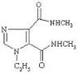
Bis-(methylamide)-1-ethylimidazole-4,5-dicarboxylic acid
It is a white crystalline powder. Bad in water, soluble in alcohol. Aqueous solutions are sterilized at pH 6.5-7.2, t° 100° temperature, for 30 minutes.
It has a stimulating effect on the subcortical parts of the brain and the centers of the medulla oblongata. Its mechanism of action on the CNS is related to the activation of purinergic receptors and increasing the level of cyclic 3', 5'-АМФ (sАМФФ).
Etimizol is used as a respiratory analeptic and narcotic and hypnotic agents during poisoning, atelectasis of the lungs, head injuries. Etimizole is effective during asphyxia and post-asphyxia in newborns. Etimizole stimulates the adrenocorticotropic function of the pituitary gland, it can be used in the treatment of bronchial asthma and arthritis. It is mainly used intramuscularly and intravenously. It is released in the form of a tablet and an injection solution.

Tetrazole derivatives
Corazol (Pentylenetetrazole)
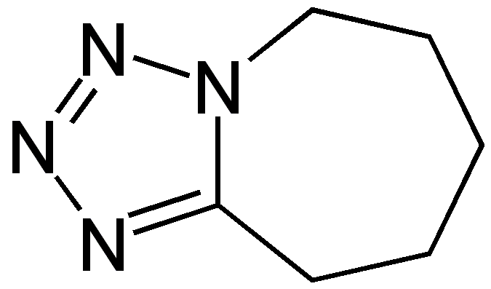
6,7,8,9-tetrahydro-5H-tetrazolo(1,5-a)azepine
It is a white crystalline powder. Easily soluble in water and alcohol. Aqueous solutions are sterilized at pH 6.0-8.0, t° 100° temperature, for 30 minutes.
Pentylenetetrazol in therapeutic doses has a stimulating effect mainly on brain stem neurons. In high doses, it causes convulsions by having a stimulating effect on the cerebral cortex and spinal cord. The mechanism of action is related to the blocking effect on the QAYT/benzodiazepine receptor complex. Pentylenetetrazol interacts with the GAYT/benzodiazepine receptor complex through the "picrotoxin binding site" - the site where barbiturates bind. Since this interaction causes disinhibition by blocking the opening of chlorine channels, it causes an analeptic effect as a result of the activation of the corresponding brain structures. Pentylenetetrazole is currently used in experimental pharmacology rather than as a medicinal substance.

10) Indole derivatives
Strychnine
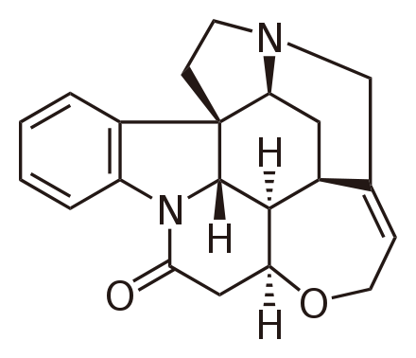
Strixnin indol alkaloidi olaraq 1818-ci ildə Pellyetle və Kaventu tərəfindən Hindistanda yetişən qusturucu köklərdən (Strychnos nux vomica adlı ağacın toxumlarından) alınan alkaloiddir.
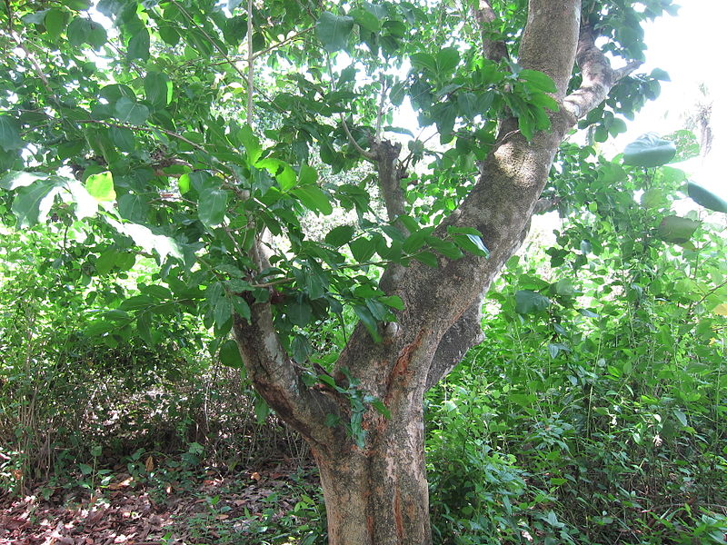

Strýchnos nux-vómica
It is a very toxic substance. It has been used in medical practice in the form of nitrate salt. Strychnine-nitrate is colorless, lustrous, needle-like crystals or white crystalline powder. It has a very bitter taste. Hardly soluble in water and alcohol, easily soluble in boiling water, insoluble in ether. Aqueous solutions are neutral and weakly acidic.
Metabolism of strychnine:
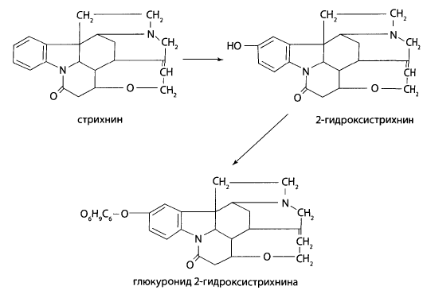
Among the convulsants, the mechanism of action is the best studied, but it has no practical significance as a medicinal substance. Research in toxicological direction is of fundamental importance. There is a certain compatibility between strychnine and tetanus toxin according to the mechanism of action. While strychnine blocks postsynaptic glycine A receptors, tetanus toxin irreversibly blocks glycine release from nerve endings. The lethal dose of the drug is 30-50 mg for adults and 15 mg for children. During strychnine poisoning, tonic convulsions reminiscent of grand epileptic seizures are observed.
Securinine
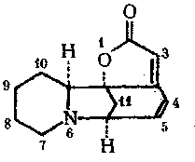
It is an alkaloid of the indole group obtained from the plant Securinega suffruticosa. It was identified in 1950 by A. Shreter and V. Chaika. It is a lemon-yellow crystalline powder. It is well soluble in ethyl alcohol and chloroform. It is difficult to dissolve in cold water. Nitrate salt is used as a medicine. Securinin is an amaleptic drug. It is close to strychnine in terms of effect, but less toxic. It is used in asthenic conditions, paresis and paralysis, in hypo- and asthenic forms of neurasthenia, in sexual weakness associated with disorders of the nervous system.
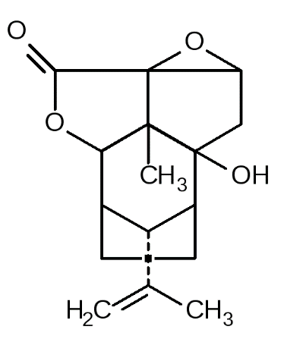
Picrotoxin

Picrotoxin is extracted from the seeds of Anamirta cocculus, a type of ivy plant. Since it does not contain nitrogen, it is not considered an alkaloid. In the body, it turns into an active metabolite - picroxine. Supraspinal neurons show higher sensitivity to picrotoxin than spinal cord neurons. It is of no practical importance as a medicinal substance. It is mainly used in experimental pharmacology.
Morpholine derivatives
Doxapram (Dopram)
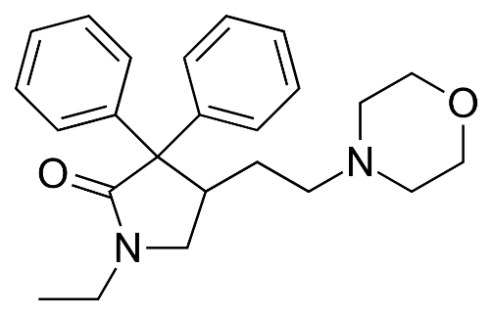
(RS)-1-ethyl-4-(2-morpholin-4-ylethyl)-3,3-diphenyl-pyrrolidin-2-one

Respirator is an analeptic agent. Recently, doxapram is used more often as an analeptic. Doxapram is a white crystalline powder. Soluble in water, slightly soluble in alcohol, practically insoluble in ether.
Its pharmacological properties are similar to drugs from the group of amphetamines. These drugs cause indirect sympathomimetic effects (e.g. increase blood pressure, etc.). Not only peripheral mechanisms, but also central mechanisms are involved in raising blood pressure. It is the drug with the largest therapeutic range among analeptics. Therefore, it is considered the safest representative of this series.
It is prescribed intravenously (slowly) as an analeptic. Against the background
of a single injection (in doses of 0.5-2 mg/kg), it causes stimulation of the respiratory center lasting up to 5-10 minutes. It is prescribed at a rate of 5 mg/minute from the beginning of the treatment until the effect is obtained; then the injection rate is reduced to 1-3 mg/min. The maximum dosage of the drug is 300 mg. In most cases, it is used in cases of poisoning caused by high doses of benzodiazepines, barbiturates, ethyl alcohol and other medicinal substances that have a blocking effect on the CNS.
Piperidine derivatives
Lobelin
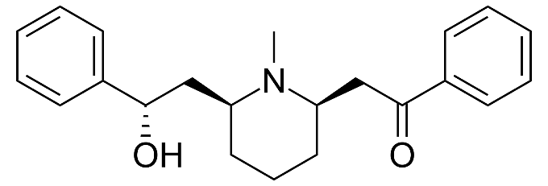
Lobelin (Lobelinum) is an alkaloid obtained from Lobelia infanta L. plant. It is a white, bitter crystalline powder. Hardly soluble in water, soluble in water. It has been used as an analeptic and respiratory stimulant in medical practice. It is used against the fight against smoking, "Lobesil" is included in the composition of the drug. It is used in tablet form.
Methylphenidate (Ritalin)

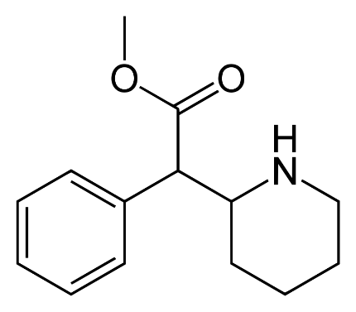

Methyl-2-phenyl-2-(piperidin-2-yl)acetate
It is an inhibitor of noradrenaline reuptake. It is a CNS stimulant, used to treat attention deficit hyperactivity disorder and narcolepsy.
In industry, 2-chloropyridine and benzyl cyanide are used.
Metabolism of methylphenidate:
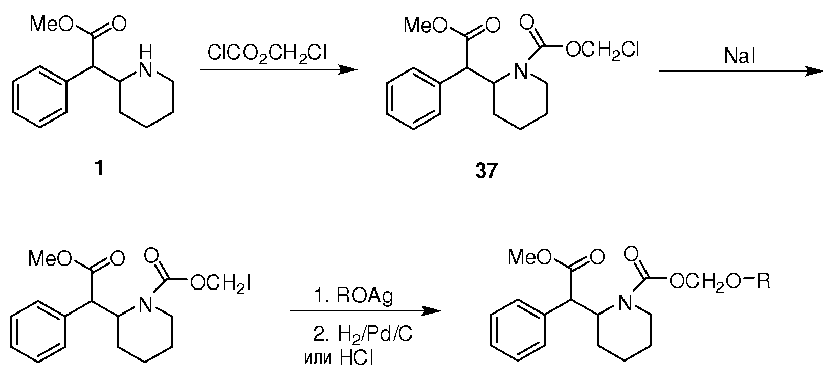

The drug is used as a psychostimulant, in asthenic conditions, high fatigue, attention deficit syndrome, side effects of antipsychotic drugs, as well as to eliminate methamphetamine addiction.
Quinolizide derivatives
Cytisine (Cititon)

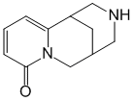

It is an N-cholinomimetic. Stimulates the ganglia of the autonomic nervous system. It has an analeptic effect. It is quickly absorbed from MBT, does not undergo metabolism, and is excreted unchanged from the liver. It is used to overcome nicotine addiction.
The property of analeptic effect is also found in barbincaine hydrochloride, as well as medicinal substances of natural origin (obtained from plant and animal raw materials) that have a "toning" effect on the CNS and are widely used in folk medicine - ginseng root, bioginseng tincture, eleutherococcus clear extract, crab lemon tincture , tincture of aralia, ecdysten, saparal, pantocrine, rantarine, etc. there are also.

